

Contents

CASSANDRA 2

Key Steps to Get Started: 2

**Key Features of Cassandra** 2

Understanding the Cassandra Architecture 3

Understanding the Cassandra Data Model 6

6

Example: Blog Application Data Model in Cassandra 9

Indexes in Cassandra 10

Column Family Compression 10

Primary Indexes 10

Secondary Indexes 11

Planning Your Data Model 11

Managing and Accessing Data in Cassandra 12

Managing and Accessing Data in Cassandra 14

Overview 14

About Writes in Cassandra 14

About Compaction 14

Transactions and Concurrency Control 14

About Inserts, Updates, and Deletes 15

About Reads in Cassandra 15

About Data Consistency in Cassandra 15

Choosing Client Consistency Levels 15

Specifying Client Consistency Levels 16

Starting the CLI 16

Creating a Keyspace 16

Creating a Column Family 17

Creating a Counter Column Family 17

Inserting Rows and Columns 18

Reading Rows and Columns 18

Setting an Expiring Column 18

Indexing a Column 19

Deleting Rows and Columns 19

Dropping Column Families and Keyspaces 19

Conclusion 19

# CASSANDRA

Apache Cassandra is a distributed NoSQL database designed to handle large amounts of data across many commodity servers, providing high availability with no single point of failure. Here are some key features and a step-by-step guide with examples based on the Apache Cassandra 1.0 documentation:

## Key Steps to Get Started:

1. **Java Prerequisites**: Ensure you have the latest version of Java installed, as it is required for running Cassandra.
2. **Downloading the Software**: Obtain the DataStax Community Edition Server, which includes the necessary tools and utilities for working with Cassandra. This can be done via direct download links or terminal commands for Linux and Mac users.
3. **Installing the Software**: Extract the downloaded tar file to install Cassandra on your system.
4. **Starting the Cassandra Server**: Start the Cassandra server using the appropriate commands for your operating system.
5. **Logging into Cassandra**: Use either the Cassandra CLI or the CQL utility to enter commands and interact with the database.

**Key Features of Cassandra**

1. **Scalability**: Cassandra scales horizontally by adding more nodes to the cluster.
2. **Fault Tolerance**: Data is replicated across multiple nodes, ensuring no single point of failure.
3. **High Availability**: Ensures 100% uptime with its peer-to-peer distributed system across data centers.
4. **Flexible Schema**: Allows dynamic column families and columns, adapting to changing application requirements.
5. **Decentralized**: No master node; all nodes are identical, simplifying maintenance and scaling.

### Understanding the Cassandra Architecture

Apache Cassandra is designed as a decentralized, distributed database system that operates as a cluster of independent nodes, each contributing to the overall functionality and resilience of the database. This section delves into the core architectural concepts that define how Cassandra manages data, handles cluster communications, and ensures fault tolerance.

#### Cluster Configuration and Peer-to-Peer Model

In Cassandra, all nodes within a cluster are peers, meaning there is no concept of a master-slave relationship. Each node communicates with others using a gossip protocol, where nodes exchange state information about themselves and other nodes they know about. This gossip protocol ensures that each node quickly learns about the state and location of all other nodes in the cluster, facilitating dynamic cluster management without a centralized coordinator.

#### Seed Nodes and Cluster Membership

When a node joins a Cassandra cluster, it identifies seed nodes specified in its configuration file. Seed nodes serve as initial contact points for new nodes to discover the cluster topology and obtain information about other nodes. It's crucial that all nodes in the cluster have the same seed node list to prevent communication partitions during startup. Seed nodes do not hold any special authority beyond facilitating the initial gossip process.

#### Data Distribution and Partitioning

Cassandra partitions data across nodes using a consistent hashing mechanism. Each node is assigned a token that determines its position within the data ring. Data is distributed evenly across nodes based on this token assignment, ensuring balanced data distribution and efficient data retrieval. The partitioning strategy is critical for scalability and performance, allowing Cassandra to handle large datasets across multiple nodes seamlessly.

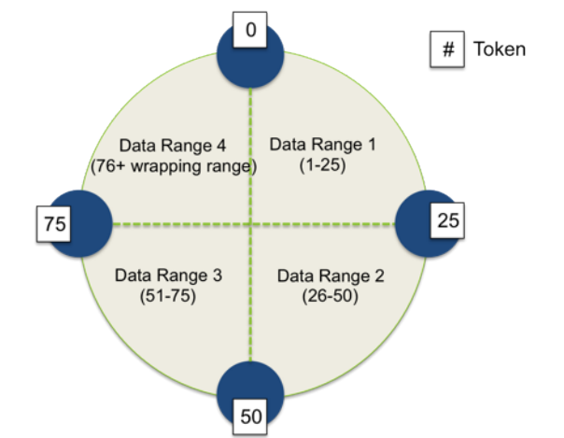

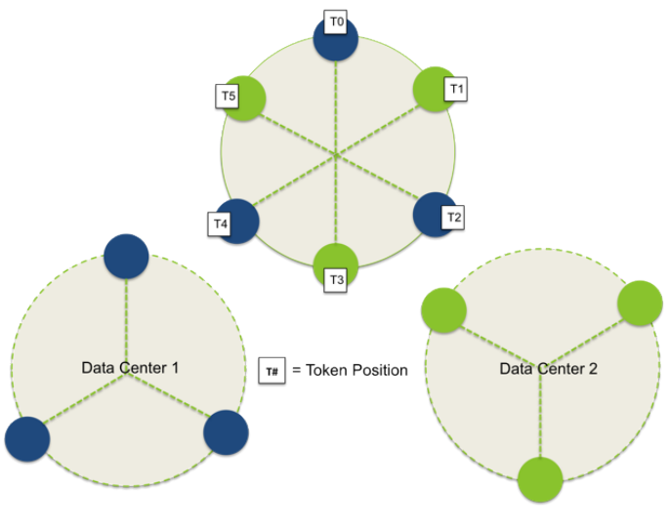

#### Failure Detection and Recovery

Cassandra employs an efficient failure detection mechanism based on the gossip protocol. Nodes exchange heartbeat messages to detect failures and unresponsiveness among peers. This dynamic failure detection mechanism adjusts to network conditions and workload variations, ensuring accurate and timely detection of node failures. Upon detecting a failure, Cassandra reroutes client requests to available nodes, maintaining high availability and data consistency.

#### Replication Strategies

To ensure fault tolerance and data durability, Cassandra replicates data across multiple nodes. Administrators define a replication factor that determines how many copies of each piece of data are stored in the cluster. Replication strategies like SimpleStrategy and NetworkTopologyStrategy dictate how replicas are distributed across nodes and data centers. NetworkTopologyStrategy is preferred for multi-data center deployments, allowing administrators to specify replica placement based on network topology and data center configuration.

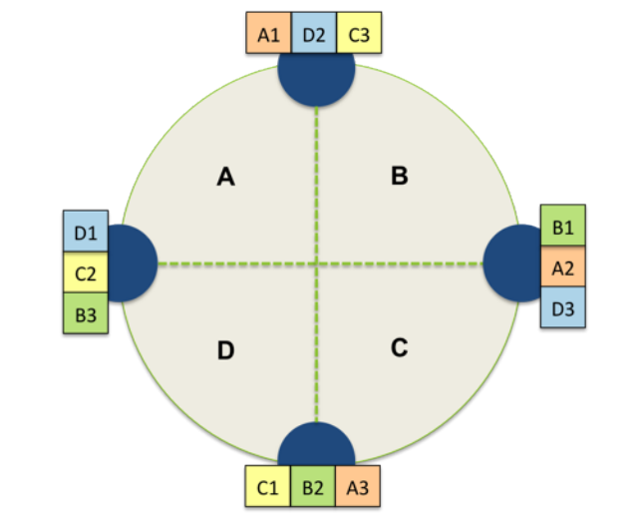

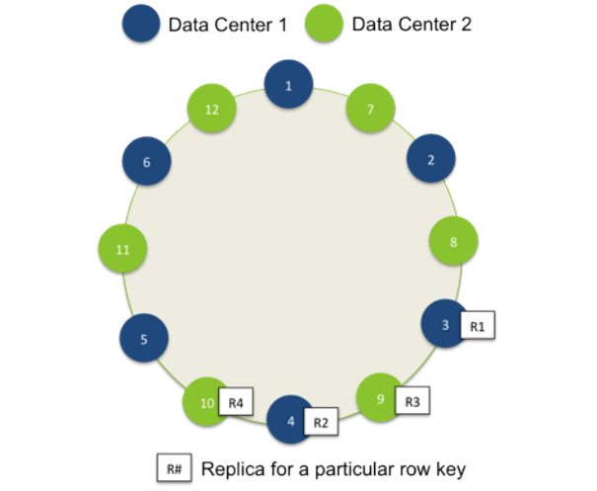

### Understanding the Cassandra Data Model

### 

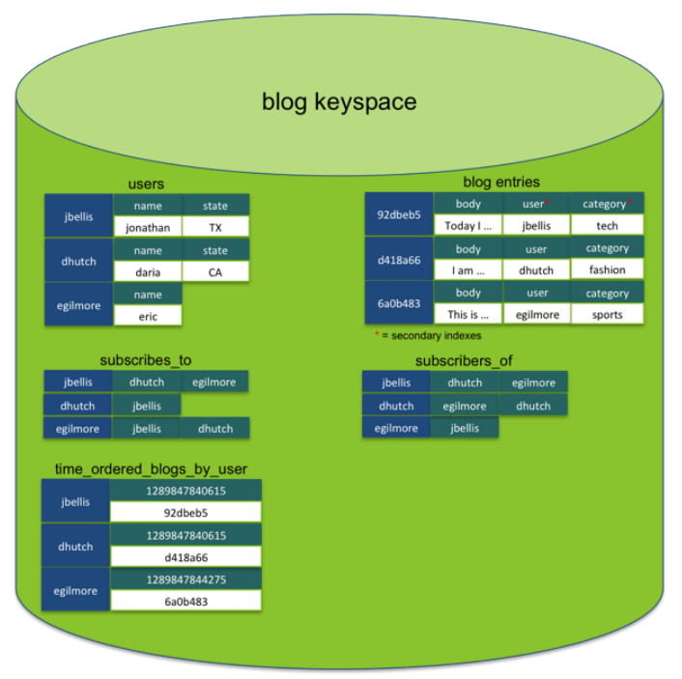

#### Key Concepts

* **Dynamic Schema:** Cassandra allows for a flexible schema where each row doesn't need to have the same set of columns, and columns can be added as needed without downtime.
* **Column-Oriented:** Data is stored in columns rather than rows, which allows for efficient retrieval of specific subsets of data.

#### Key Components

1. **Keyspace:**
   * **Definition:** A keyspace in Cassandra is a container for data, similar to a database in relational systems. It groups multiple column families.
   * **Replication:** Controlled at the keyspace level, ensuring data redundancy and availability.

CREATE KEYSPACE example_keyspace WITH

strategy_class = 'SimpleStrategy'

AND strategy_options:replication_factor=2;

1. **Column Family:**
   * **Definition:** Analogous to tables in relational databases, column families store data rows, each identified by a unique row key.
   * **Types:**
     + **Static Column Families:** Have a relatively fixed set of columns, similar to relational tables.
     + **Dynamic Column Families:** Use arbitrary column names set by the application, useful for pre-computed result sets or materialized views.

CREATE COLUMN FAMILY users WITH

key_validation_class=UTF8Type AND

column_metadata = [

{column_name: name, validation_class: UTF8Type},

{column_name: email, validation_class: UTF8Type},

{column_name: state, validation_class: UTF8Type},

{column_name: gender, validation_class: UTF8Type},

{column_name: birth_year, validation_class: LongType}

]

AND compression_options={sstable_compression:SnappyCompressor, chunk_length_kb:64};

1. **Columns:**
   * **Structure:** A column is a tuple of a name, value, and timestamp.
   * **Types of Special Columns:**
     + **Expiring Columns:** Have a TTL (time-to-live) after which they are marked as deleted.
     + **Counter Columns:** Store incrementing values, useful for counting occurrences.
     + **Super Columns:** Group multiple columns into a single entity, providing an additional level of nesting.

#### Differences from Relational Databases

* **No Joins:** Cassandra does not support joins between column families. Data retrieval relies on denormalization and designing column families to efficiently answer specific queries.
* **No Foreign Keys:** Relationships between column families are not enforced by the database.
* **Denormalization:** Often necessary to store data in a way that supports efficient queries.

#### Designing Column Families

* **Static Column Families:** Suitable for structured data where rows generally share the same set of columns.
* **Dynamic Column Families:** Useful for unstructured or semi-structured data where rows may have varying columns.

#### Data Types

* **Validators and Comparators:** Define the data types for row keys, column names, and values.
  + **Validators:** For column values (e.g., UTF8Type, LongType).
  + **Comparators:** For column names to ensure sorted order within a row (e.g., TimeUUIDType).

CREATE COLUMN FAMILY user_activity WITH

key_validation_class=UTF8Type AND

default_validation_class=UTF8Type AND

comparator=UTF8Type;

#### Compression

* **Benefits:** Improves storage efficiency and read/write performance.
* **Configuration:** Can be set at the column family level, with options for compression type and chunk size.

CREATE COLUMN FAMILY logs WITH

compression_options={sstable_compression:SnappyCompressor, chunk_length_kb:64};

### Example: Blog Application Data Model in Cassandra

#### Keyspace Definition

CREATE KEYSPACE blog_app WITH

strategy_class = 'SimpleStrategy'

AND strategy_options:replication_factor=2;

#### Column Families

1. **Users Column Family:**

CREATE COLUMN FAMILY users WITH

key_validation_class=UTF8Type AND

column_metadata = [

{column_name: user_id, validation_class: UUIDType},

{column_name: username, validation_class: UTF8Type},

{column_name: email, validation_class: UTF8Type}

];

1. **Blog Entries Column Family:**

CREATE COLUMN FAMILY blog_entries WITH

key_validation_class=UUIDType AND

column_metadata = [

{column_name: entry_id, validation_class: UUIDType},

{column_name: user_id, validation_class: UUIDType},

{column_name: category, validation_class: UTF8Type},

{column_name: content, validation_class: UTF8Type},

{column_name: created_at, validation_class: DateType}

];

1. **Subscriptions Column Family (Dynamic):**

CREATE COLUMN FAMILY subscriptions WITH

key_validation_class=UUIDType AND

comparator=UTF8Type;

This model supports queries like:

* "What users subscribe to my blog?"
* "Show me all blog entries about fashion."
* "Show me the most recent entries for the blogs I subscribe to."

By designing additional column families or secondary indexes, Cassandra ensures efficient data retrieval for specific application needs.

### Indexes in Cassandra

An index in Cassandra is a data structure that allows for the efficient lookup of data matching a given condition. This enhances the performance of read operations by enabling faster searches based on specific criteria.

### Column Family Compression

Column family compression in Cassandra helps reduce the storage footprint by compressing the data stored within column families. This can lead to significant storage savings and improved read performance, as less data needs to be read from disk.

### Primary Indexes

In relational databases, a primary key is a unique identifier for each row in a table, ensuring record uniqueness and often influencing the physical storage order of records. A primary key index speeds up data access.

In Cassandra, the primary index is the index of a column family's row keys, maintained by each node for the data it manages. Rows are assigned to nodes based on the partitioner and replica placement strategy configured for the cluster and keyspace. The primary index enables efficient row lookups by their row key, with each node knowing the key ranges it manages.

Using a randomly partitioned row key (the default in Cassandra) involves partitioning by MD5 hash, preventing ordered scans like traditional B-tree indexes. Ordered partitioners allow range queries over rows but can cause uneven data distribution across nodes.

### Secondary Indexes

Secondary indexes in Cassandra index column values, allowing efficient querying by specific values using equality predicates. They are best for columns with many rows sharing the same value, such as a state column in a user table. Cassandra supports KEYS-type secondary indexes, similar to hash indexes.

For columns with unique values, such as email addresses, manually maintaining a dynamic column family as an index can be more efficient. Despite this, secondary indexes can be convenient for unique data if the query volume is moderate.

Secondary indexes are easy to populate and maintain. They can be created during column family definition or added later, with existing data indexed in the background.

Example of creating a secondary index during column family definition:

create column family users with comparator=UTF8Type

and column_metadata=[

{column_name: full_name, validation_class: UTF8Type},

{column_name: email, validation_class: UTF8Type},

{column_name: birth_year, validation_class: LongType, index_type: KEYS},

{column_name: state, validation_class: UTF8Type, index_type: KEYS}

];

Adding an index to an existing column family:

update column family users with comparator=UTF8Type

and column_metadata=[

{column_name: full_name, validation_class: UTF8Type},

{column_name: email, validation_class: UTF8Type},

{column_name: birth_year, validation_class: LongType, index_type: KEYS},

{column_name: state, validation_class: UTF8Type, index_type: KEYS}

];

Querying with the secondary index:

get users where state = 'TX';

### Planning Your Data Model

#### Start with Queries

Design your Cassandra data model by starting with the queries your application needs to support and working backward. Identify the actions your application performs and the data access patterns, considering ordering, filtering, and grouping requirements.

#### Denormalize to Optimize

Unlike relational databases, Cassandra favors denormalization to optimize performance. Data needed to satisfy a query should be located in the same column family, sacrificing disk space for reduced disk seeks and network traffic.

#### Planning for Concurrent Writes

Every row in a column family is identified by a unique row key. Cassandra does not enforce uniqueness, so inserting a duplicate row key will upsert the columns rather than return a unique constraint violation.

#### Using Natural or Surrogate Row Keys

Decide between natural keys (unique data values) and surrogate keys (generated unique identifiers like UUIDs). Natural keys are more readable but may require additional handling for uniqueness and updates. Surrogate keys avoid these issues but are less human-readable.

#### UUID Types for Column Names

Use UUIDType to avoid collisions in column names, especially for columns identified by timestamps. Type-1 (time-based) UUIDs prevent timestamp collisions during simultaneous writes, ensuring data integrity.

### Managing and Accessing Data in Cassandra

Cassandra is designed for high availability and fast, efficient data management. Here is an overview of key concepts related to managing and accessing data in Cassandra:

#### About Writes in Cassandra

Cassandra is optimized for very fast and highly available data writing. Unlike relational databases, which are structured to minimize data duplication, Cassandra prioritizes write throughput and durability.

* **Write Process**: Writes are first written to a commit log for durability and then to an in-memory structure called a memtable. Once in the commit log and memory, the write is considered successful. Periodically, memtables are flushed to disk into SSTables (Sorted String Tables).
* **SSTables**: These are immutable, meaning once data is written to an SSTable, it is not altered. This immutability requires merging data from multiple SSTables and memtables during read operations.
* **Bloom Filters**: To optimize reads, Cassandra uses bloom filters. Each SSTable has an associated bloom filter to check if a requested row key exists in the SSTable before any disk I/O occurs.

#### About Compaction

Compaction in Cassandra is the process of merging SSTables. This process helps in:

* Merging row fragments together.
* Removing expired tombstones (markers for deleted columns).
* Rebuilding primary and secondary indexes.

There are two main compaction strategies:

* **Size-Tiered Compaction**: Suitable for write-heavy workloads.
* **Leveled Compaction**: Suitable for read-heavy workloads.

#### About Transactions and Concurrency Control

Cassandra does not offer fully ACID-compliant transactions but ensures high availability and fast write performance:

* **Atomicity**: Writes are atomic at the row level.
* **Consistency**: Managed through tunable consistency levels.
* **Isolation**: Not supported at the level of multiple rows or column families.
* **Durability**: Ensured by writing to a commit log.

#### About Inserts and Updates

* **Upserts**: Inserting a duplicate row key results in an upsert, updating existing columns if they exist or inserting new ones.
* **Timestamps**: Updates are based on timestamps provided by the client, so synchronized clocks across client machines are essential.

#### About Deletes

* **Tombstones**: Deleted data is marked with tombstones instead of being immediately removed. These tombstones are eventually removed during compaction.
* **Node Repair**: Regular node repair is necessary to prevent deleted data from reappearing, especially if a node is down for an extended period.
* **Range Queries**: Deleted rows may still appear in range query results until tombstones are cleared by compaction.

#### About Hinted Handoff Writes

Hinted handoff helps ensure consistency when a node is temporarily down:

* **Hints**: If a replica node is down, another live replica stores a hint containing the location and data for the write.
* **Write Consistency Level ANY**: This level provides absolute write availability, storing the hint and data on the coordinator node if all replicas are down. However, it can lead to inconsistencies until the actual replicas receive the data.

#### Key Concepts and Terminology

* **Memtable**: An in-memory table where writes are initially stored.
* **SSTable**: A disk-based table where memtables are flushed.
* **Bloom Filter**: A probabilistic data structure to quickly check if a key is present in an SSTable.
* **Commit Log**: A durable log of all write operations.
* **Tombstone**: A marker indicating a column or row has been deleted.
* **Hinted Handoff**: A mechanism to ensure writes succeed even if some replicas are down.

## Managing and Accessing Data in Cassandra

### Overview

Cassandra is a highly performant and available distributed database system optimized for fast data writes. It offers various client utilities and APIs for developing applications that leverage its data storage and retrieval capabilities.

### About Writes in Cassandra

Cassandra is designed for high-speed, highly available writes, differing significantly from traditional relational databases. Here's how it works:

1. **Commit Log and Memtable**: Writes are first written to a commit log for durability and then to an in-memory table structure called a memtable. This minimizes disk I/O at the time of write.
2. **SSTables**: Writes are batched in memory and periodically flushed to disk into SSTables (Sorted String Tables). SSTables are immutable and organized sequentially, reducing random disk I/O.
3. **Bloom Filters**: To optimize read performance, Cassandra uses bloom filters, which check for the presence of a requested row key in an SSTable before performing any disk I/O.

### About Compaction

Cassandra performs a process called compaction to merge SSTables, remove expired tombstones (deleted columns), and rebuild indexes. Compaction improves read performance but temporarily increases disk I/O and space usage.

### Transactions and Concurrency Control

Cassandra does not support fully ACID-compliant transactions. It offers atomic writes at the row level but does not bundle multiple row updates into one operation or roll back partial failures. Consistency is managed using timestamps provided by client applications, and writes are durable, recorded in both memory and the commit log.

### About Inserts, Updates, and Deletes

* **Inserts and Updates**: Columns are upserted (updated if they exist, inserted if they don't) using unique row keys. Timestamps ensure the most recent data persists.
* **Deletes**: Deleted data is marked with tombstones and removed during compaction. Regular node repair prevents deleted data from reappearing due to prolonged node downtimes.

### About Reads in Cassandra

Cassandra reads combine data from all relevant SSTables and memtables. Bloom filters optimize this process by minimizing unnecessary disk I/O. The built-in key cache and optional row cache further enhance read performance.

### About Data Consistency in Cassandra

Cassandra supports tunable consistency, allowing clients to balance between consistency and availability based on application needs. Consistency levels for reads and writes can be set to ensure desired data accuracy and response times.

#### Write Consistency Levels

* **ANY**: A write must be acknowledged by at least one node, allowing for high availability at the cost of potential consistency.
* **ONE**: A write must be acknowledged by one replica node.
* **QUORUM**: A write must be acknowledged by a majority of replica nodes.
* **LOCAL_QUORUM**: A write must be acknowledged by a majority of replica nodes in the same data center.
* **EACH_QUORUM**: A write must be acknowledged by a majority of replica nodes in each data center.
* **ALL**: A write must be acknowledged by all replica nodes.

#### Read Consistency Levels

* **ONE**: Returns a response from the closest replica, with background read repairs ensuring consistency over time.
* **QUORUM**: Returns the most recent data once a majority of replicas have responded.
* **LOCAL_QUORUM**: Similar to QUORUM but confined to replicas in the same data center.
* **EACH_QUORUM**: Similar to QUORUM but requires responses from a majority of replicas in each data center.
* **ALL**: Requires responses from all replicas, ensuring the highest consistency but lowest availability.

### Choosing Client Consistency Levels

The choice of consistency levels depends on the application's requirements for data consistency versus response time. For example, QUORUM ensures strong consistency, while ONE or ANY prioritizes availability.

### Specifying Client Consistency Levels

Consistency levels are specified in client requests. For instance, in CQL (Cassandra Query Language), the default consistency level for reads and writes is ONE, but it can be adjusted as needed:

SELECT * FROM users WHERE state='TX' USING CONSISTENCY QUORUM;

To get started using the Cassandra CLI, you need to understand how to perform basic data definition (DDL) and data manipulation (DML) operations. Here’s a step-by-step guide:

### Starting the CLI

1. **Locate the Cassandra CLI**:
   * Packaged installations: /usr/bin/cassandra-cli
   * Binary installations: $CASSANDRA_HOME/bin/cassandra-cli
2. **Connect to a Cassandra Instance**:
   * Single-node cluster on localhost:

cassandra-cli -host localhost -port 9160

* + Multi-node cluster:

cassandra-cli -host 110.123.4.5 -port 9160

1. **Get Help**:
   * General help:

[default@unknown] help;

* + Help on a specific command:

[default@unknown] help SET;

### Creating a Keyspace

To create a keyspace called demo with a replication factor of 1 and using the SimpleStrategy replica placement strategy:

[default@unknown] CREATE KEYSPACE demo

WITH placement_strategy = 'org.apache.cassandra.locator.SimpleStrategy'

AND strategy_options = [{replication_factor:1}];

Verify the creation of the keyspace:

[default@unknown] SHOW KEYSPACES;

### Creating a Column Family

1. **Connect to the Keyspace**:

[default@unknown] USE demo;

1. **Create a Static Column Family**:

[default@demo] CREATE COLUMN FAMILY users

WITH comparator = UTF8Type

AND key_validation_class=UTF8Type

AND column_metadata = [

{column_name: full_name, validation_class: UTF8Type},

{column_name: email, validation_class: UTF8Type},

{column_name: state, validation_class: UTF8Type},

{column_name: gender, validation_class: UTF8Type},

{column_name: birth_year, validation_class: LongType}

];

1. **Create a Dynamic Column Family**:

[default@demo] CREATE COLUMN FAMILY blog_entry

WITH comparator = TimeUUIDType

AND key_validation_class=UTF8Type

AND default_validation_class = UTF8Type;

### Creating a Counter Column Family

1. **Define a Counter Column Family**:

[default@demo] CREATE COLUMN FAMILY page_view_counts

WITH default_validation_class=CounterColumnType

AND key_validation_class=UTF8Type

AND comparator=UTF8Type;

1. **Insert and Increment Counter**:
   * Insert:

[default@demo] INCR page_view_counts['www.datastax.com'][home] BY 0;

* + Increment:

[default@demo] INCR page_view_counts['www.datastax.com'][home] BY 1;

### Inserting Rows and Columns

1. **Insert Columns into users Column Family**:
   * Example with row key bobbyjo:

[default@demo] SET users['bobbyjo']['full_name']='Robert Jones';

[default@demo] SET users['bobbyjo']['email']='bobjones@gmail.com';

[default@demo] SET users['bobbyjo']['state']='TX';

[default@demo] SET users['bobbyjo']['gender']='M';

[default@demo] SET users['bobbyjo']['birth_year']='1975';

* + Example with row key yomama:

[default@demo] SET users['yomama']['full_name']='Cathy Smith';

[default@demo] SET users['yomama']['state']='CA';

[default@demo] SET users['yomama']['gender']='F';

[default@demo] SET users['yomama']['birth_year']='1969';

1. **Insert into blog_entry Column Family**:

[default@demo] SET blog_entry['yomama'][timeuuid()] = 'I love my new shoes!';

### Reading Rows and Columns

1. **Retrieve Rows**:

[default@demo] LIST users;

1. **Retrieve a Specific Row**:

[default@demo] GET users[utf8('bobbyjo')][utf8('full_name')];

1. **Assume Encoding**:

[default@demo] ASSUME users KEYS AS ascii;

[default@demo] ASSUME users COMPARATOR AS ascii;

[default@demo] ASSUME users VALIDATOR AS ascii;

### Setting an Expiring Column

To set a column with a TTL (time-to-live):

[default@demo] SET users['bobbyjo'][utf8('coupon_code')] = utf8('SAVE20') WITH ttl=864000;

### Indexing a Column

Add a secondary index:

[default@demo] UPDATE COLUMN FAMILY users

WITH comparator = UTF8Type

AND column_metadata = [{column_name: birth_year, validation_class: LongType, index_type: KEYS}];

Query using the secondary index:

[default@demo] GET users WHERE birth_date = 1969;

### Deleting Rows and Columns

1. **Delete a Column**:

[default@demo] DEL users['yomama']['coupon_code'];

1. **Delete a Row**:

[default@demo] DEL users['yomama'];

### Dropping Column Families and Keyspaces

1. **Drop a Column Family**:

[default@demo] DROP COLUMN FAMILY users;

1. **Drop a Keyspace**:

[default@demo] DROP KEYSPACE demo;

### Conclusion

This documentation has provided a comprehensive overview of using both the Cassandra CLI and CQL (Cassandra Query Language) to interact with Apache Cassandra. Whether you are an administrator setting up and managing keyspaces and column families or a developer performing data operations, these tools offer robust functionality and flexibility.

The Cassandra CLI client utility allows for basic data definition (DDL) and data manipulation (DML) within a Cassandra cluster. It offers straightforward commands for creating keyspaces, defining column families, inserting and retrieving data, and managing indexes. Despite being powerful, it requires familiarity with the underlying Cassandra data model and architecture.

On the other hand, CQL presents a more intuitive and SQL-like approach to interacting with Cassandra. Through the cqlsh command-line interface, users can perform a variety of database operations, from creating keyspaces and column families to inserting, updating, and deleting data. CQL also supports indexing and setting column expiration times, providing a richer set of features for modern database management.

Both the Cassandra CLI and CQL have their unique strengths, making them suitable for different use cases and user preferences. The CLI offers low-level control and detailed configuration options, while CQL provides a more accessible and user-friendly interface for everyday database tasks.

By leveraging the capabilities of both tools, users can effectively manage their Cassandra databases, ensuring optimal performance, scalability, and reliability. For advanced features and further learning, consulting the official Cassandra documentation and exploring additional resources will be beneficial.

This guide serves as a foundational reference, equipping you with the knowledge to start working with Cassandra and utilize its full potential in your applications and infrastructure.